Day 5: (task 5)
Aim: SQL Joins (Inner Join, Left Join, Right Join, Full Join)
1. Inner Join: (This query will show the names and age of students enrolled in different courses.)
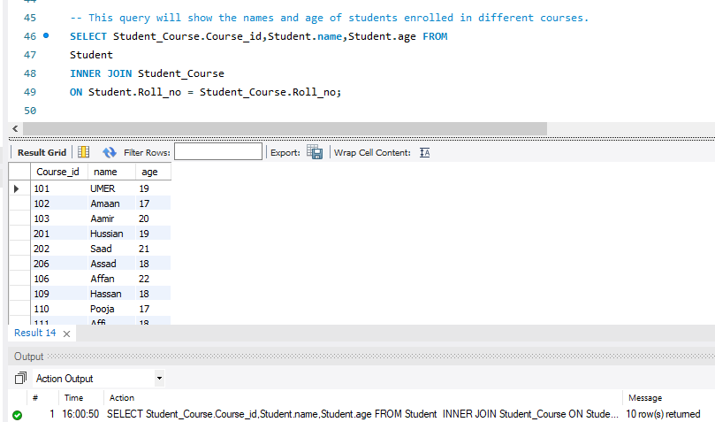
2. Left Join: (retrieves all rows from the Student table and the matching rows from the Student_Course table based on the ROLL_NO column.)
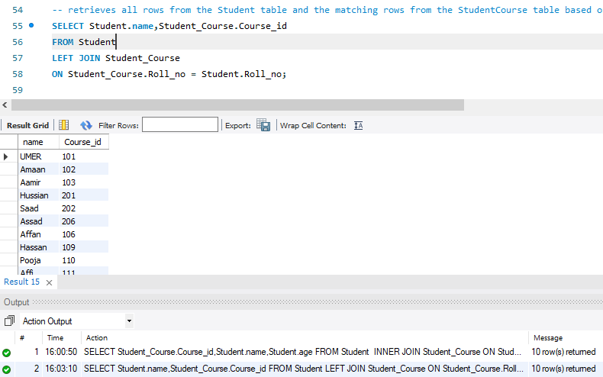

3. Right join: (retrieves all rows from the Student_Course table and the matching rows from the Student table based on the ROLL_NO column.)
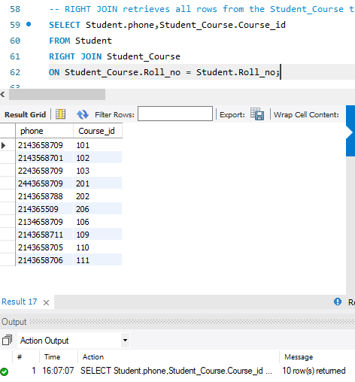
4. Full join: (used for union)
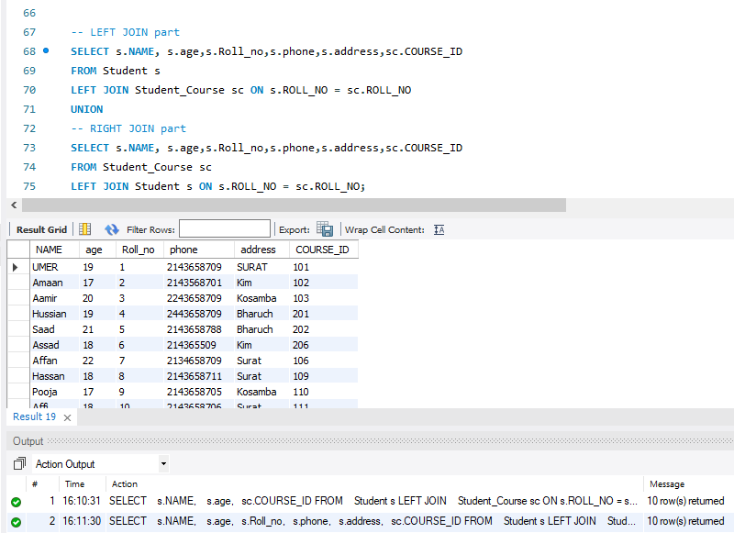
5. Cross Join: (we will use the CROSS JOIN command to match the data of the Employee and Department table.)
